Before Your Site Inspection — Risks to Consider
(Sent attached to the site inspection calendar invite. Purpose: plant risk-awareness only — no All Cleared branding. The client should be thinking about these before the estimator arrives, so they ask the questions on-site and the estimator provides the solutions live. The Methodology question is deliberately left unanswered here — it gets addressed later via the process document, provided once the quote is finalised.)
WHAT YOU SHOULD KNOW

Asbestos
Asbestos is always a cost to the project. But the real cost isn't the asbestos everyone expects to find — it's the overlooked, detailed areas.
Common hidden locations include:
- Under bearers and joists acting as packers
- Backing boards behind switchboards
- Behind wall and ceiling linings (concealed, double lined)
- Underneath flooring, in soil from building off-cuts
- Concealed beneath concrete slabs
- Used as formwork to concrete foundations
Most of these areas are never inspected and these being overlooked can drive significant cost to your project.

Photo Evidence — Examples from Recent Site Inspections
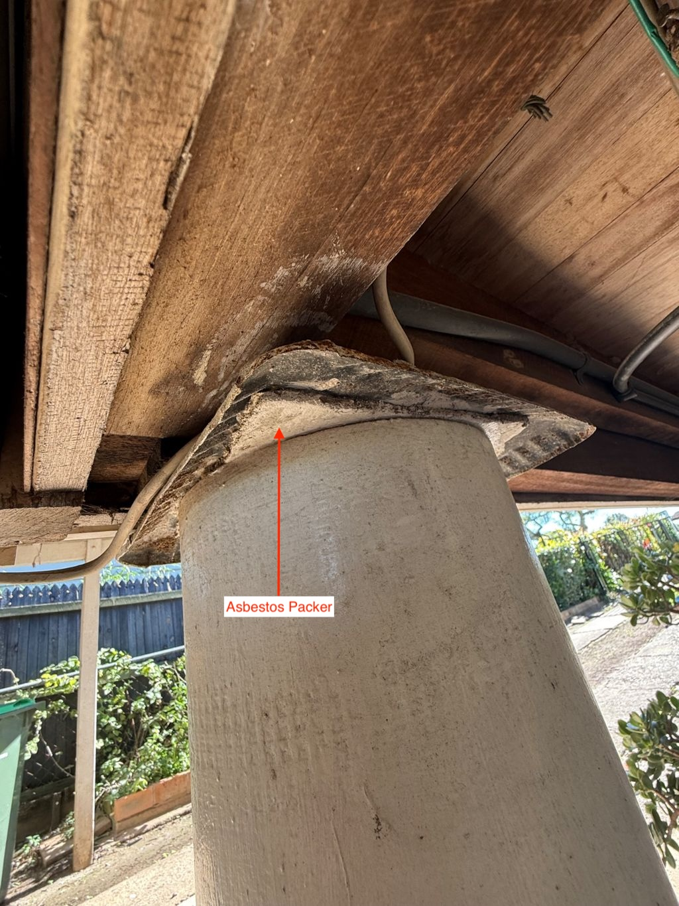  Asbestos packer — under bearers/joists | 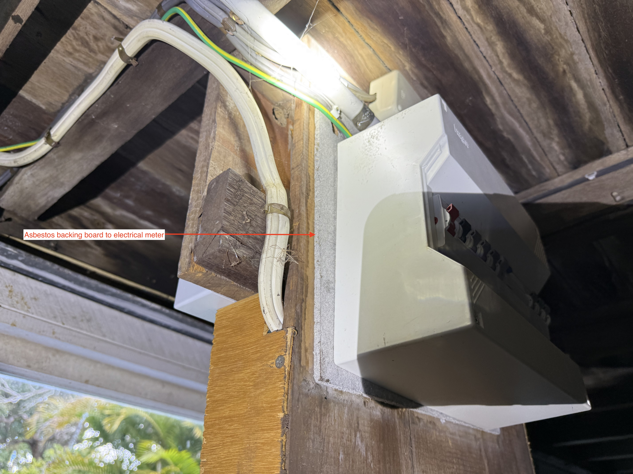  Asbestos backing board behind switchboard/meter
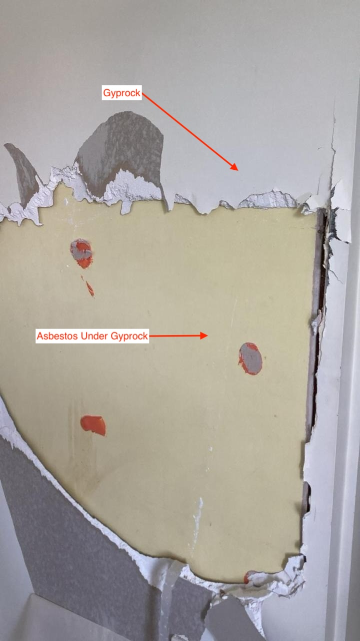  Asbestos sheet concealed under gyprock (wall lining) | 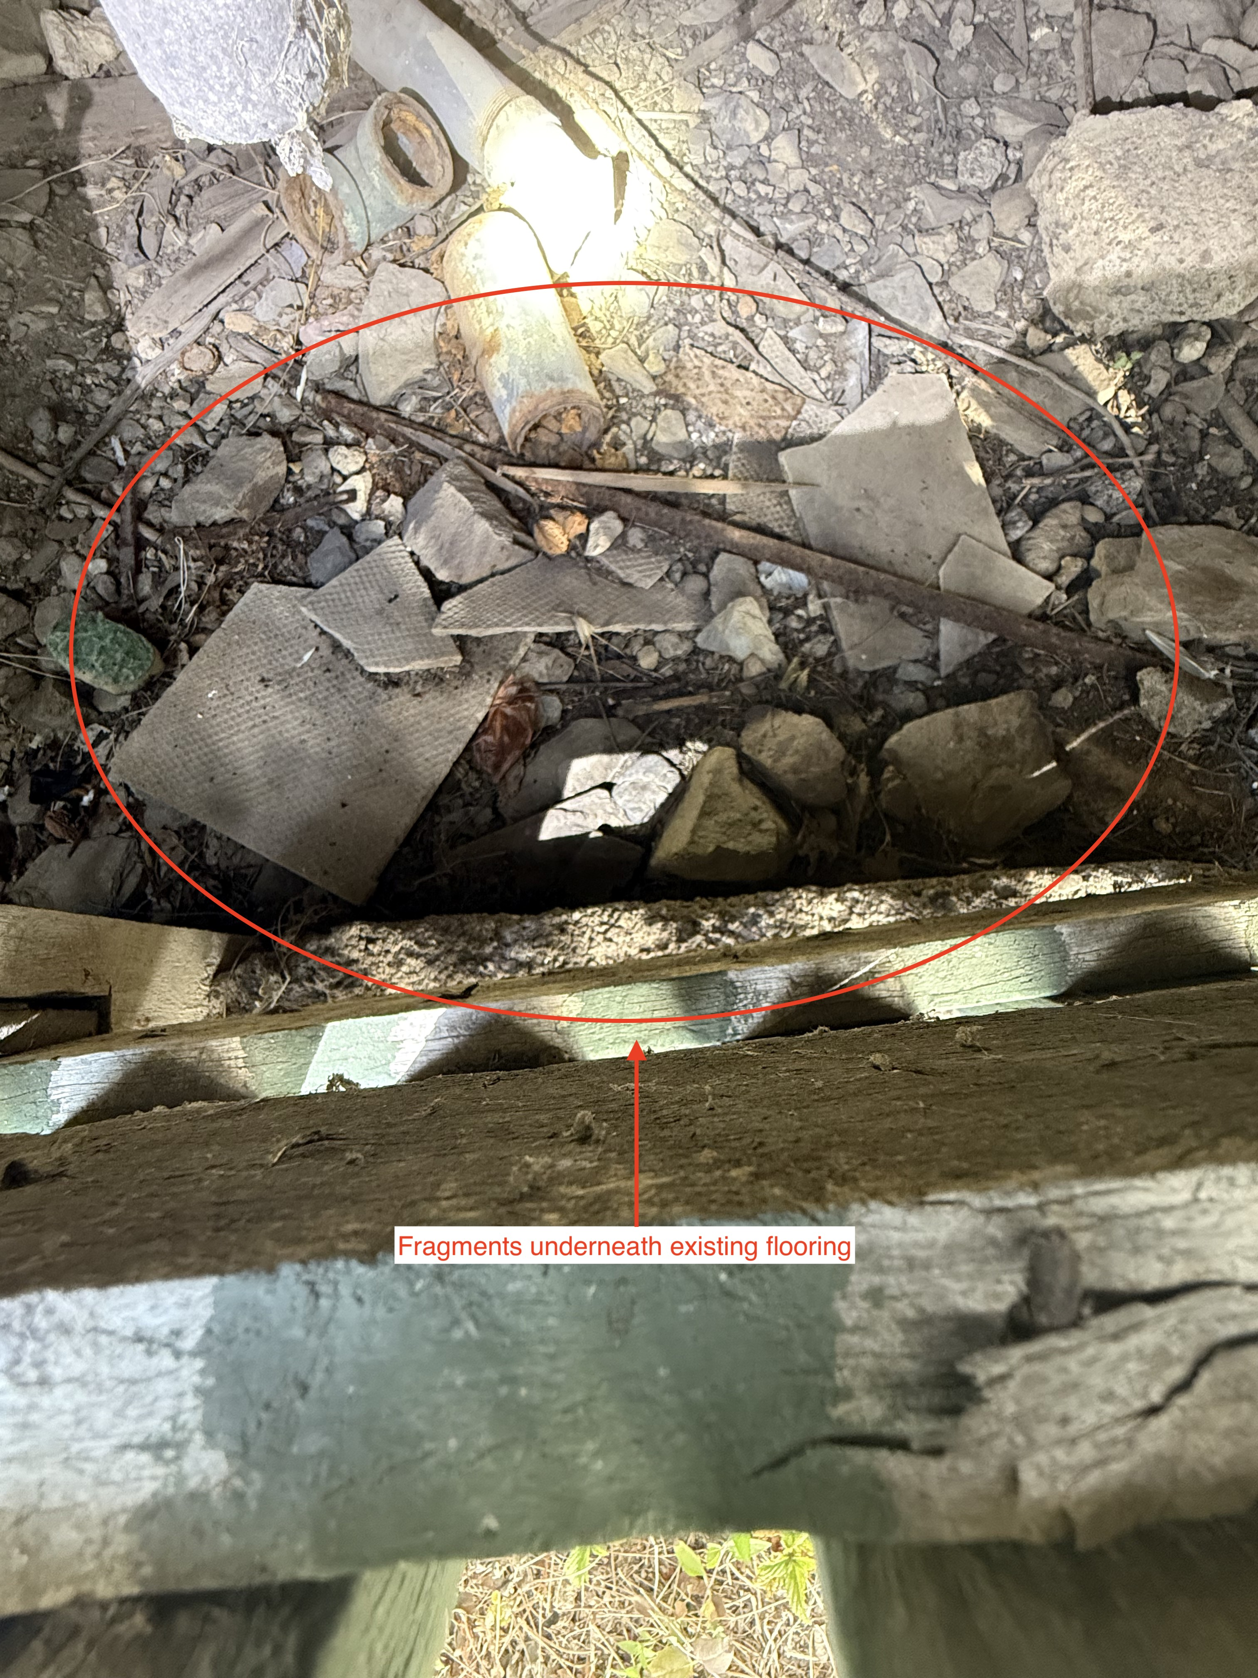  Asbestos fragments underneath existing flooring
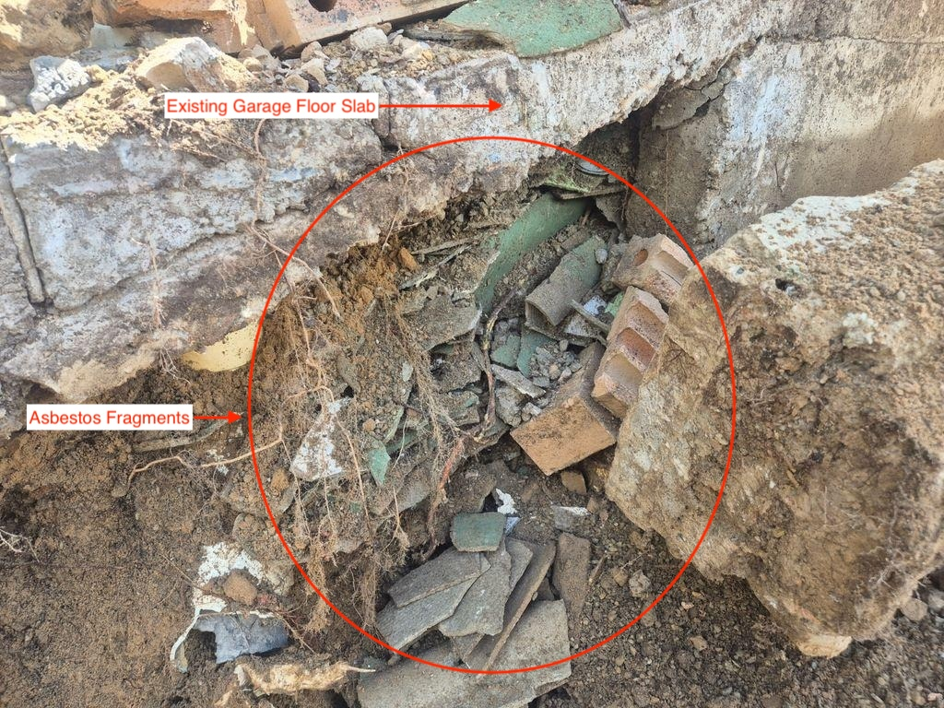  Asbestos fragments concealed beneath concrete slab | 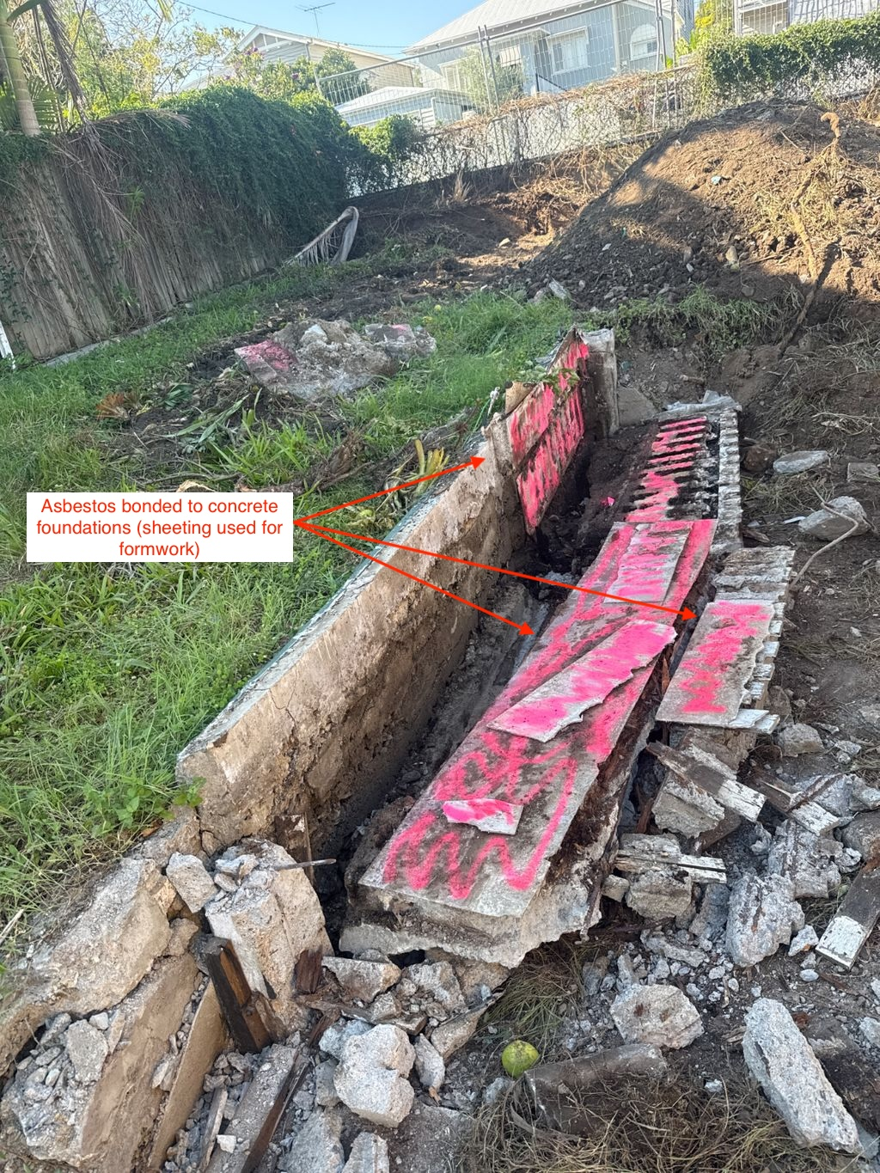  Asbestos sheeting used as formwork to concrete foundations

Methodology
How a contractor actually plans and executes a job affects both the outcome and the risk of things going wrong. Not every contractor works the same way.
QUESTIONS TO ASK YOUR CONTRACTOR
- Do you have a demolition methodology to mitigate variations? If so, what is it?
- Do you provide an in-house asbestos clearance certificate, or engage an independent hygienist to issue it?
- What are your payment terms? (e.g. 25% deposit, 25% upon asbestos removal, 25% upon machine mobilisation, balance on completion — a payment structure weighted heavily upfront can suggest the contractor is pre-empting additional costs or variations, and is structuring payments to protect themselves from not being paid in full once that conversation happens.)
- What is the size of your team? How many operators do you have?
- If our abolishments aren't done in time, how will you reschedule?
STATUS: DRAFT — pending review

